Trace levels

Instrumentation needs to support different levels of operation, from high performance production systems through to developmental debugging.

Usually there are several levels of event type of increasing detail. The structure of the levels can be considered a pyramid, with each level having less importance but a higher volume of events:

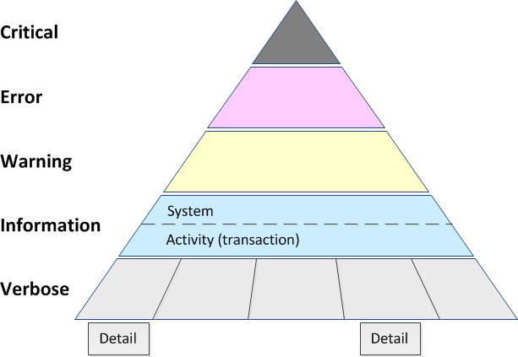

There should be few (hopefully no) critical events, maybe a few errors, and hopefully more warnings than errors; information events and activities should be relatively regular occurrences, but not an overwhelming volume, while there would be a large volume of verbose and more detailed tracing – if it was all turned on at once.

Usually you want all Critical, Error, Warning events reported in the trace; Information and Activity Tracing is also important for context, but can add modest volume.

However, turning on all verbose events as a single level would usually result in an overwhelming volume of information, so it is common to partition this level up into separate functions that can be individual turned on or off, e.g. a separate TraceSource (and SourceSwitch) for each area.

For particular low level and high volume detailed information, it may be necessary to have even individual control flags (BooleanSwitch) whether to trace or not, e.g. writing full request/response details to the trace.

Your application may have a different set of levels or in a different order, for example SharePoint has Critical, Warning, Unexpected, Monitorable, Information, High, Medium, Verbose, and VerboseEx, but the general principal of increasing detail and volume of messages at each level still applies.

Logging vs tracing

A distinction should be made between the concepts of logging and tracing (although sometimes the terminology used is unclear).

Logging provides an audit trail of significant events for your application. An example is services or applications writing to the Windows event log when they start or stop, and when an error (such as an unexpected exception) occurs. This also covers application logs of activity such as the HTTP Logging provided by IIS.

System logging, such as writing to the Windows event log, does not have to be configurable – usually you always want these events to be reported and it doesn’t make sense to be able to turn them off. These events correspond to the Information through Critical levels above.

Application logs usually contain structured data about the activity being logged. The volume of activities is usually more than system events so often application logging is configurable to turn on and off (but with separate configuration than tracing).

As well as logs, system events and activities may also be monitored through Windows Performance Monitor (perfmon) counters.

Tracing, in contrast, is designed to provide lower level information for detailed diagnostics and debugging. Events should be consistent with logging (i.e. tracing should include all Critical, Error, Warning, Information and activity events) but is usually configurable.

Although the higher levels provide context for the trace, the gritty details correspond to the Verbose level, or even finer grained detail controlled by individual boolean switches. (Another option is to simply have additional trace sources for the finer detail.)

Diagnostics strategy

For each level in your diagnostics model, you should plan the logging, monitoring and tracing strategies you will use. For example, with the levels above:

Type | Description | Logging | Monitoring | Tracing
Critical |  | Windows event log (Error) |  | SourceSwitch*
Error | System or task permanent failure, such as an unexpected exception. At system level the system is not functioning; at task level the task has failed. In some cases a task level error may be considered a system level warning. | Windows event log (Error) | Errors/sec | SourceSwitch*
Warning | System or task temporary/partial failure. Task or component will be re-attempted or continue. Also for true warnings (almost failures), e.g. a resource is running low. | Windows event log (Warning) | Resource level (where appropriate) | SourceSwitch*
Information | Successful system events. e.g. start, stop, other significant one-off or rare events. | Windows event log (Information) |  | SourceSwitch*
Activities | Successful tasks, usually expected to be repeated multiple times. e.g. each transaction or each message processed. | Application log | Trans./sec  Total trans. | SourceSwitch with Activity Tracing (start, stop, etc)
Verbose | System/task major steps to identify areas for further investigation (debug information); should not produce more detail than can be handled manually. |  |  | SourceSwitch
Detail | Detail steps within a task; rather than overwhelm a trace file with details, tracing at this level should be broken up into multiple parallel Boolean Switches. |  |  | BooleanSwitch
* Note: Normally a SourceSwitch will either be off (no tracing) or turned on with at least Information level of logging.

Instrumentation consistency

Handling of events should be consistent between the different mechanisms. Applications should ensure trace events are written at the same time they are written to the Windows event log or application log, and the same time that performance monitor counters are updated.

It can make troubleshooting difficult if a transactions/second performance counter increases but there is no entry in the application log; of if there is an entry in the application log but no start/stop in the trace.

One way to implement this is have an application specific diagnostics component that provides a central location for logging, tracing and monitoring. This can have convenience methods for logging exceptions, errors, warnings, etc that write to the Windows event log, update performance counters, and trace all at one time.

The central component can also provide any custom application logging and convenience methods for simple verbose tracing. This component would be application specific, as each application’s logging needs would be different, although a general template can be followed.

Applications should also use a consistent Windows event log “source”. If the application is a Windows Service, then the service name should be used as the event log source. Otherwise, the application name (as it appears in Windows) should be used. Note that you need to install event log sources (as administrator) before they can be used.

Events that demand the immediate attention of the system administrator, e.g. an application or system has failed or stopped responding.

Events that indicate problems or errors that should be investigated and fixed, for example unexpected exceptions.

Events that provide forewarning of potential problems or data that can be collected and analysed over time, looking for problem trends

Events that pass noncritical information to the administrator, such as a server start, stop or other significant (but infrequent) event.

For logging and tracing each operation performed by an application

Useful primarily to help developers debug low-level code failures.

Useful for traces that are likely to be high volume, especially information that is not needed for all debugging scenarios.

; although not a response to an actual error, a warning indicates that a component or application is not in an ideal state and that some further actions could result in a critical error.
Events that pass noncritical information to the administrator, similar to a note that says: "For your information."
Verbose status, such as progress or success messages.

Event Level Guidelines

When defining an event in your Manifest.xml file, it is important that you choose an appropriate severity level. The severity level of an event is displayed in the Windows Event Log and is used by administrators and registered by monitoring tools to indicate how severe or important an event is. Choosing an appropriate level is a key part of the health and monitoring design for your component or system.
For more information about the event manifest schema, see Event Schema
ULS Level Name | Level ID | Shown in Event Log as… | Description
Critical Error | 30 | Critical | Events that demand the immediate attention of the system administrator. They are generally directed at the global (system-wide) level, such as System or Application. They can also be used to indicate that an application or system has failed or stopped responding.
Error | 40 | Error | Events that indicate problems, but in a category that does not require immediate attention.
Warning | 50 | Warning | Events that provide forewarning of potential problems; although not a response to an actual error, a warning indicates that a component or application is not in an ideal state and that some further actions could result in a critical error.
Information | 80 | Informational | Events that pass noncritical information to the administrator, similar to a note that says: "For your information."
Verbose | 100 | Informational | Verbose status, such as progress or success messages.
Trace Level Guidelines

When writing a trace log by using the ULS API, you must specify a severity level. The severity level is displayed in the ULS trace log and is commonly used by reporting or filtering tools. For this reason, it is important to choose an appropriate level.
ULS Level Name | Level ID | Description
Unexpected | 10 | Similar to an Assert (an assumption in code that a condition is true at a particular point), this message indicates that a logic check failed that is atypical, or the message returns an unexpected error code. These generally represent code bugs that should be investigated and fixed.
Monitorable | 15 | Traces that indicate a problem, but do not need immediate investigation. The intent is to collect data and analyze it over time, looking for problem trends.
High | 20 | General functional detail, the high priority events that happen in the environment. Examples include global configuration modifications, service start and stop, timer jobs completed, and so on.
Medium | 50 | Useful to help support or test teams debug customer or environmental issues. These likely include messages indicating that individual features have succeeded or failed, such as creating a new list, modifying a page, and so on.
Verbose | 100 | Useful primarily to help developers debug low-level code failures. Not generally useful to anyone who does not have access to source code or symbols. Most event tracing that does not need to be enabled all the time should be set at the Verbose level.
VerboseEx | 200 | Useful for traces that are likely to be high volume, especially information that is not needed for all debugging scenarios. Examples of situations where you should use the VerboseEx setting are method entry and exit events, tracing in loops, or to relay information that is not useful to developers outside your team.

